**Study Kid**

**User Manual**

**Unzip the study kid folder and open folder dp and open Microsoft visual studio file with name dp.**

**Click on build solution and run the app using “Emulator WVGA 512 mb.”**

**or**

**Install the app on phone by using visual studio.**

**After installation open the search bar in phone and search for study kid as shown in below fig**

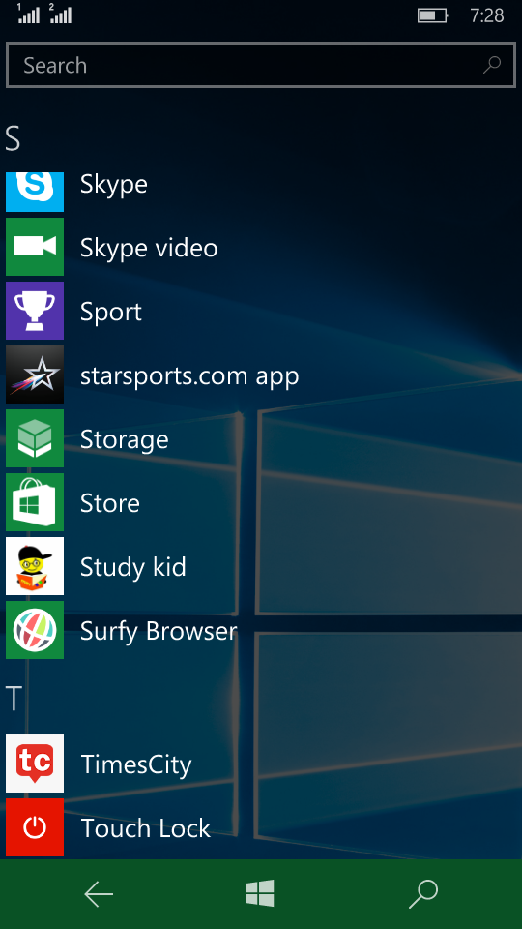

Study kid

**Now click on “study kid”.**

**Welcome page is displayed to enter into next page tap anywhere on the screen.**

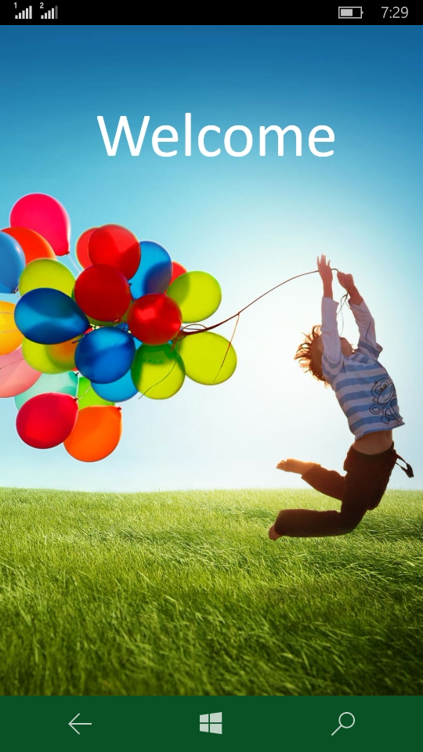

**After tapping the screen we can see three different modules**

* **Blind**
* **Deaf**
* **Others(dumb)**

**When we entered this page we can hear a voice message for blind children for knowing them navigations.**

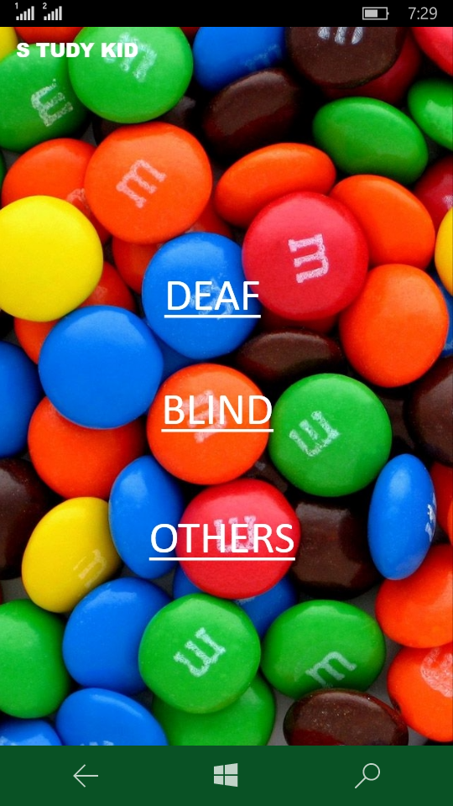

**Deaf:**

**Click on deaf then deaf module is activated**

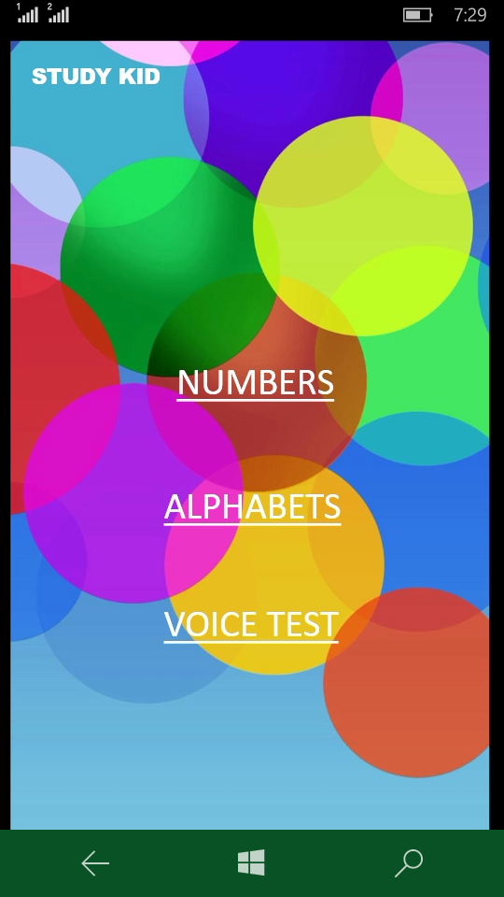

**It consists three sub modules**

* **Numbers**
* **Alphabets**
* **Voice test**

**By clicking Numbers we can watch the slide show of numbers from 1-10**

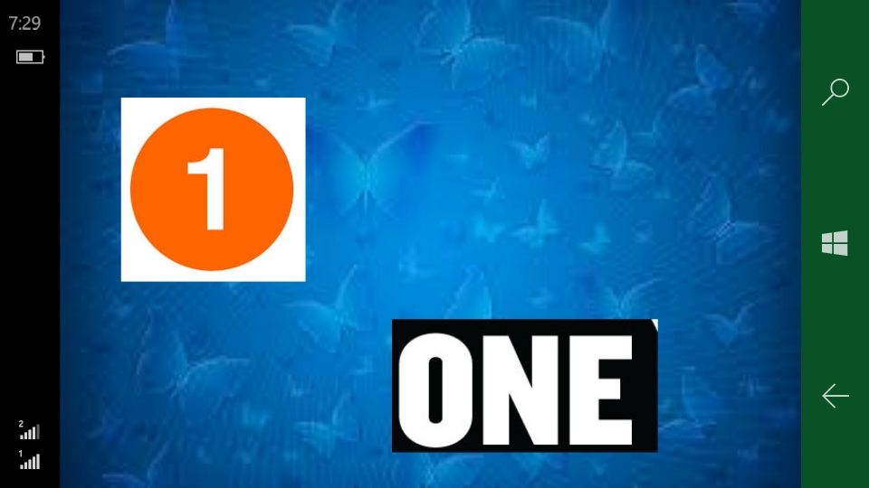

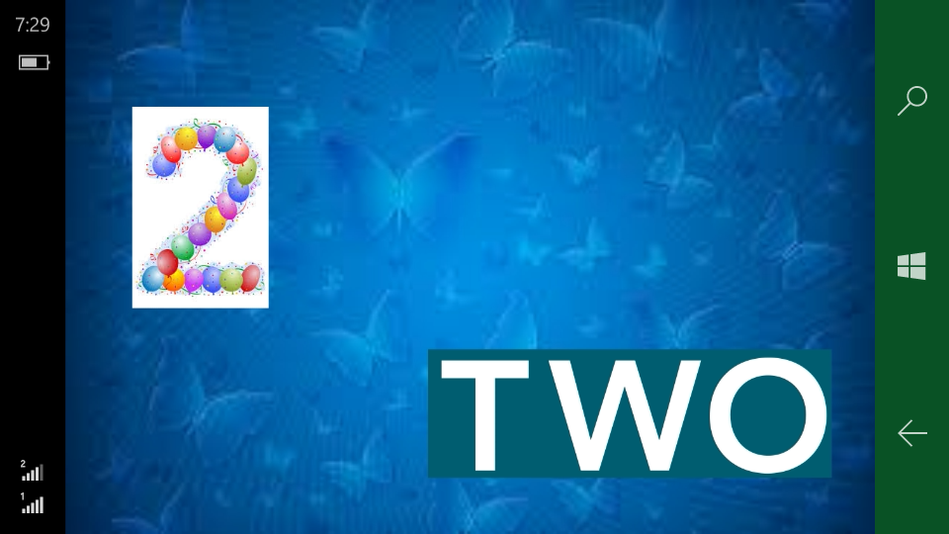

**By clicking alphabets we can watch the slide show of alphabets from A-Z.**

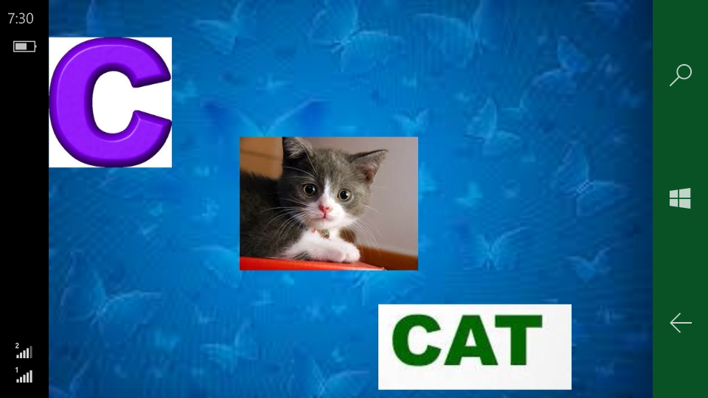

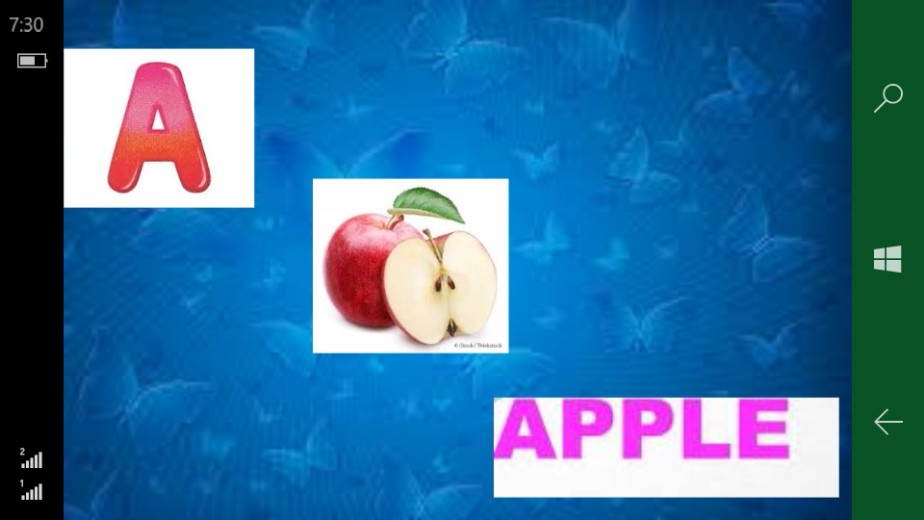

**The voice to test is used to make the children to pronounce the words correctly**

**When they click on speak and said any word correctly then it displayed on the screen. This makes the children pronunciation of words correctly**

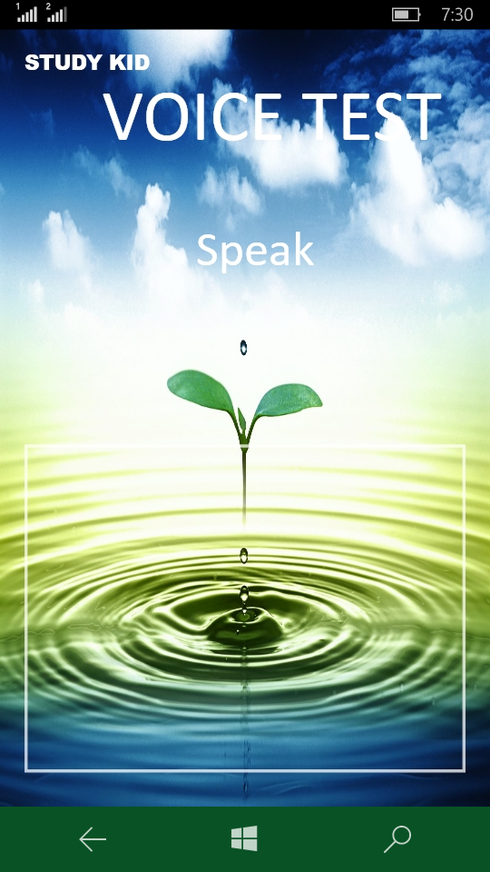

**Blind:**

**Blind mode can be activated by tapping anywhere on the screen.**



**When we tap anywhere automatically blind mode activated and gives a notification message in the form of text like “blind mode activated”, enters into next page and gives voice messages to blind children.**

**The message is “tap the above to listen alphabets and below to numbers”.**

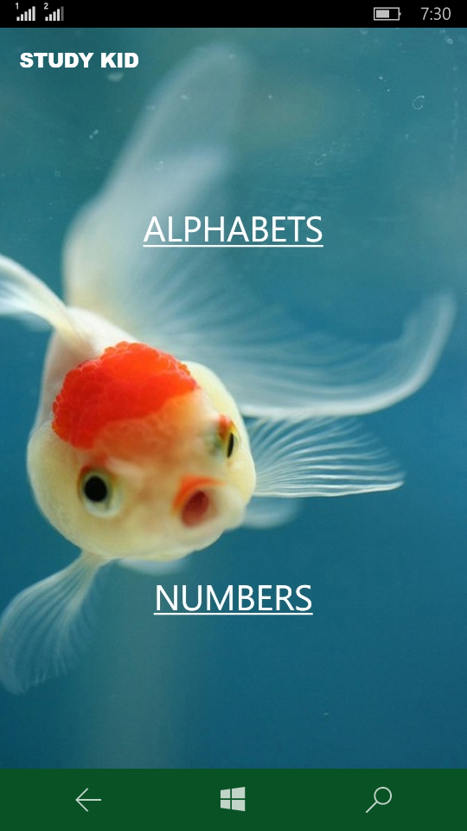

**When they tap on the above part of the screen they listen the song of alphabets they can pause the song any time by simply tapping the screen anywhere and restart any time by tapping the screen anywhere.**

**By this the blind children can learn the alphabets easily. The main aim for using song is they can remember song easily.**

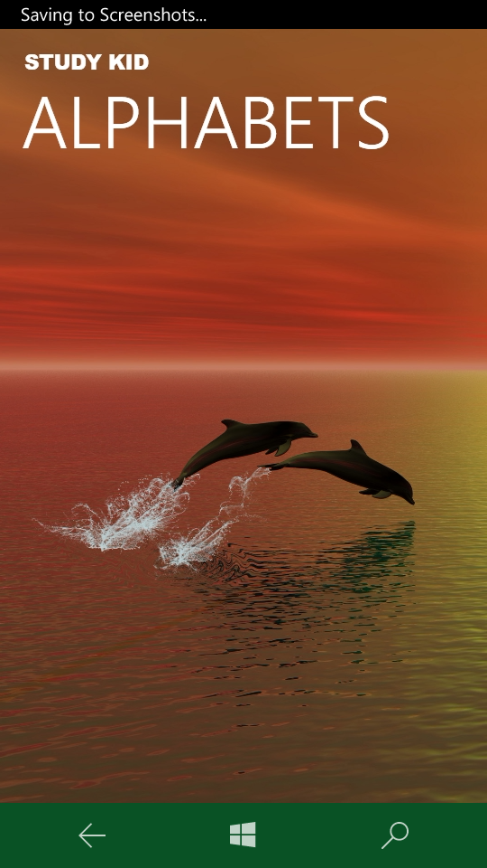

**When they tap on the below part of the screen they listen the song of numbers they can pause the song any time by simply tapping the screen anywhere and restart any time by tapping the screen anywhere.**

**By this the blind children can learn the alphabets easily. The main aim for using song is they can remember song easily.**

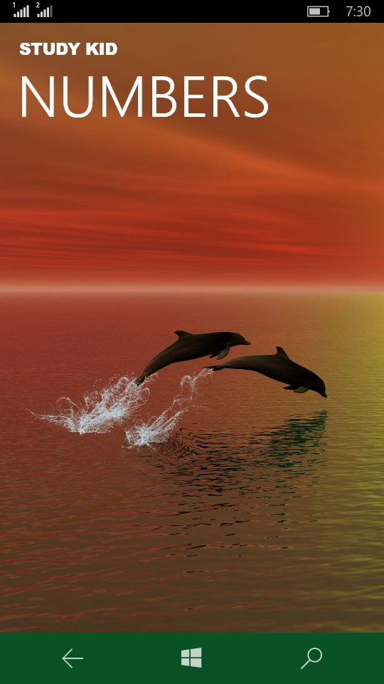

**Others (dumb):**

**We can select this by simply clicking on others**

**when we click on others it displays two modules**

* **Numbers**
* **Alphabets**

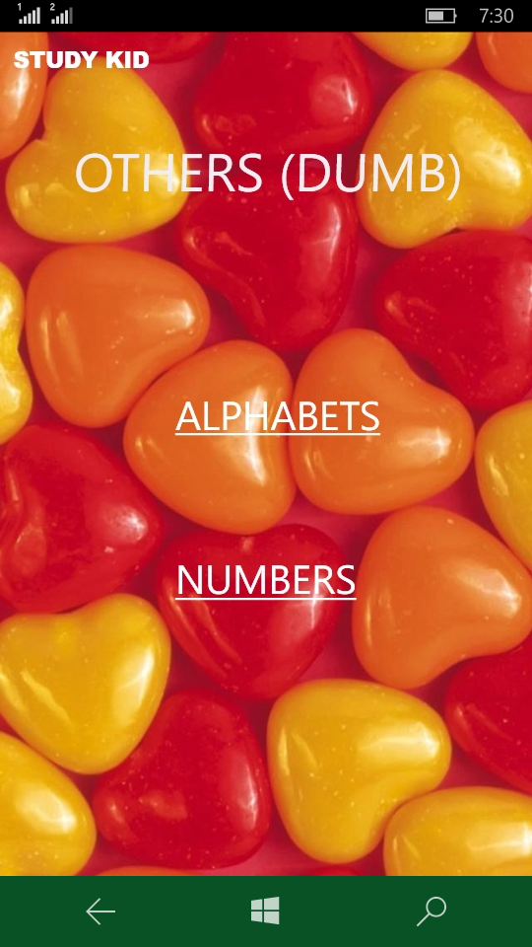

**When we click on Alphabets it plays the song of numbers by teaching alphabets to children. By seeing the video the children can learn more**

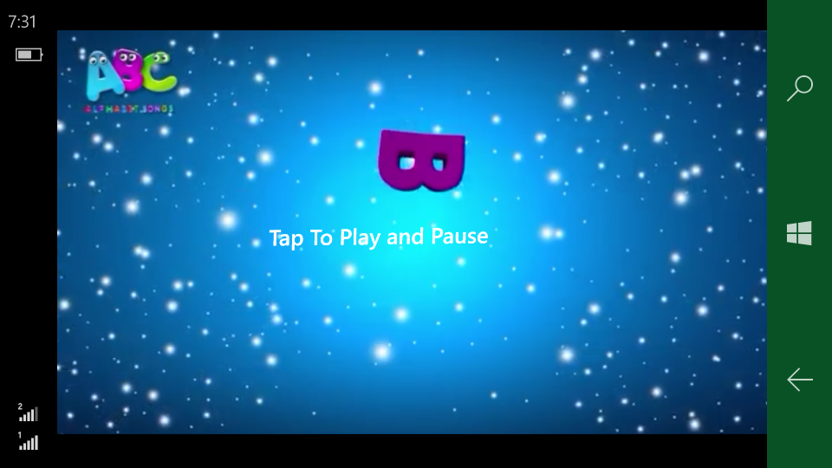

**We can play the video by tapping the screen anywhere and we can pause it by tapping the screen anywhere.**

**When we click on numbers it plays the song of numbers by teaching numbers to children. By seeing the video the children can learn more**

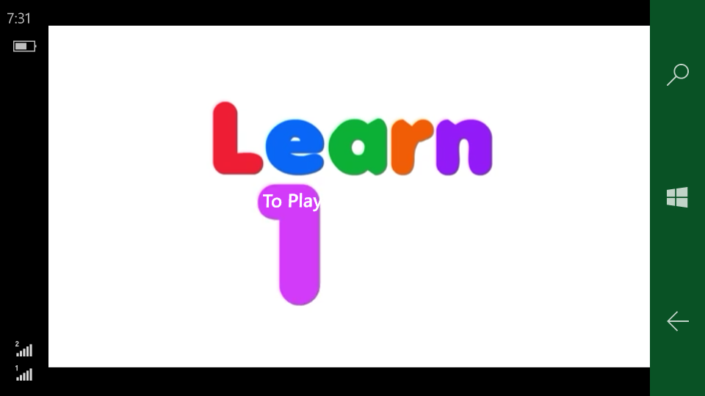

**We can play the video by tapping the screen anywhere and we can pause it by tapping the screen anywhere.**